Lab Practical #04:

Installation of Network Simulator (Packet Tracer) and Implement different LAN topologies.

**Practical Assignment #04:**

1. **Create a simple network with switch and two or more pc. Also check connectivity between them using ping command or PDU utility.**

|  |
| --- |
|  |
|  |

1. **Implement different topologies in packet tracer.**
   1. **Bus**
   2. **Ring**
   3. **Star**
   4. **Mesh**
   5. **Tree**

**Instructions:**

1. Topology-wise Screenshot.
2. Mention IP address of each pc as label.
3. Ping command or PDU screenshot between two pcs.

# Bus

|  |  |
| --- | --- |
|  |  |

# Ring

|  |  |
| --- | --- |
|  |  |

# Star

|  |  |
| --- | --- |
|  |  |

# Mesh

|  |  |
| --- | --- |
|  |  |

# Tree

|  |  |
| --- | --- |
|  |  |

# DNS Topology:

1.bus:

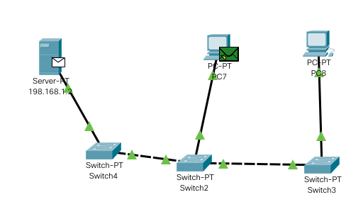

2.ring:

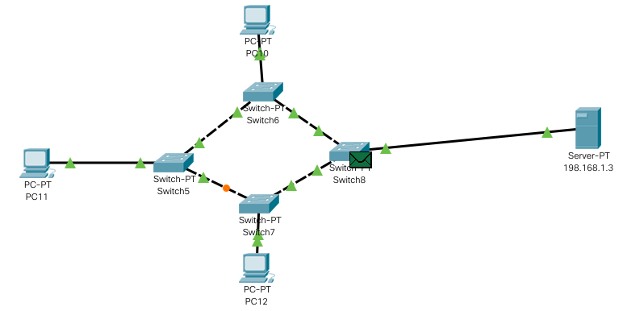

3.star:

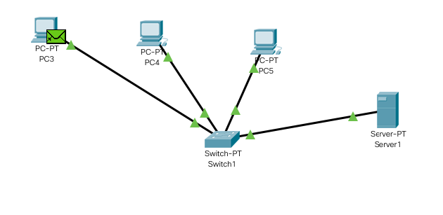

4.mesh:

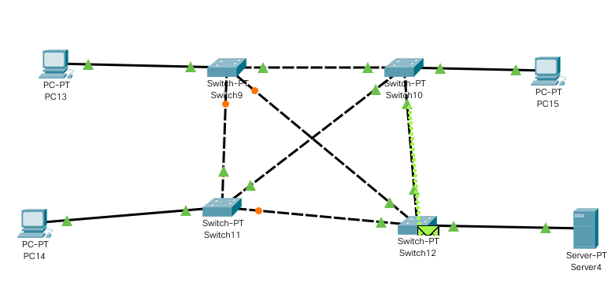

5.tree:

